MOBILE PHONE - STORE MANAGEMENT SYSTEM

Software Requirements Specification
Version 3.0

Danang, Jan 2015

TABLE OF CONTENTS
TABLE OF CONTENTS 2
1. DOCUMENT HISTORY 3
2. REFERENCE DOCUMENTS 3
3. DISTRIBUTION LIST AND APPROVALS 3
4. INTRODUCTION 3
4.1 Purpose 3
4.2 In Scope 4
5. OVERVIEW 4
5.1 Actors 4
5.2 System Use Case Diagram 5
5.3 System Pages Flow 9
6. Functional Description 10
6.1 User interface: 10
6.2 Products Management: 11
6.3 Assets Management: 20
6.4 Staff Management 29
6.5 Report 34
7. NON-FUNCTIONAL REQUIREMENTS AND OTHERS 38
Performance 38
Scalability 38
Security 38
Network 38
Backup and restore 39
Reliability 39
Interfaces 39
User manual and help 39
Extensibility 39
8. APPENDIX 40

DOCUMENT HISTORY
Date | Summary of Changes | Version
22/1/2015 | Release the first version of the SRS document | 1.0
29/1/2015 | These changes followed the comments of stakeholder (i.e. reviewer AnNPT):  - System’s Purpose and Non-Functional Requirements by Binh Pham.  - Overview (diagrams: admin roles and user roles) by Cung Vo.  - Functional Description by Dung Pham.  - Synthesis and Editing by Chanh Le (team leader). | 2.0
5/2/2015 | These changes followed the comments of stakeholder  - Overview (diagrams: admin roles and user roles) by Cung Vo and Chanh Le.  - Functional Description by Dung Pham and Binh Pham. | 3.0

REFERENCE DOCUMENTS
Document Name | Description
Software Requirements Specification Order Room Management System | ORMS_SRS_v1.2_EN.docx  Dot Net Team – FPT software
Object Oriented Analysis and Design | Slides  A. Prof. Dr. Nguyen Thanh Binh – IT Faculty, DUT
Software Engineering | Slides  A. Prof. Dr. Nguyen Thanh Binh – IT Faculty, DUT

DISTRIBUTION LIST AND APPROVALS
This document is distributed to the following stakeholders to get their valuable comments and corrections.
Name | Title

INTRODUCTION

Purpose
- This project, Mobile phone store management system is a software allow manager to manage a mobile phone store, to keep staff and every selling activities under control, by this way, he is aware the status of his store, he could manage his budget and come up with a strategy business in order to get a maximum value from that.

In Scope
- The scope pertains to the Mobile Phone - Store Management. It focuses on the store, products, staffs, selling activities, delivering and applications, which allow for online sales, distribution and marketing.
- This SRS is also aimed at specifying requirements of software to be developed but it can also be applied to assist in the selection of in-house and commercial software products. The standard can be used to create software requirements specifications directly or can be used as a model for defining an organization or project specific standard. It does not identify any specific method, nomenclature or tool for preparing an SRS.

OVERVIEW

Actors
The below diagram describes all actors of the Mobile Phone - Store Management System. An actor represents a User Role; currently we have Administrator and Normal User Account. Each user has his own actions when accessing into the system.

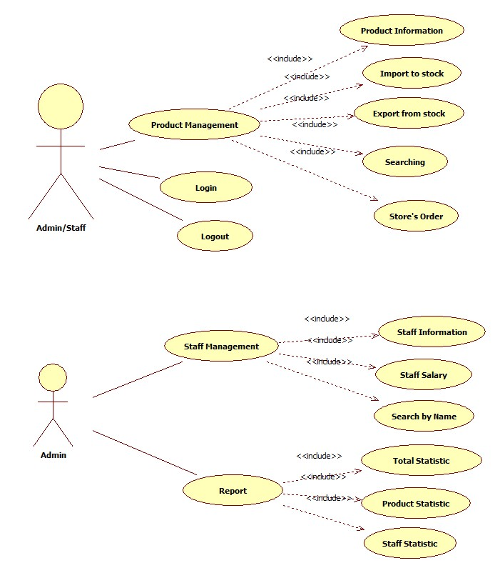
Actor | Description
Administrator | Has the right to View, Add new, Update and Delete data in all modules.
Normal User Account | Has the right to View, Add new, Update and Delete data in all modules, except User Accounts Maintenance and Report.

System Use Case Diagram
The following diagram provides an overall picture of the functionality groups, Actors of the Mobile Phone - Store Management System. Mobile Phone - Store Management System’s functionalities are divided into these use cases:

Product Management

Product Information
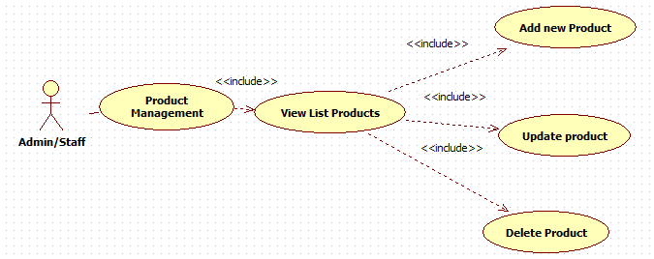

Import to stock
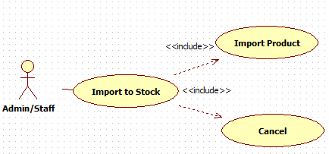

Export from stock
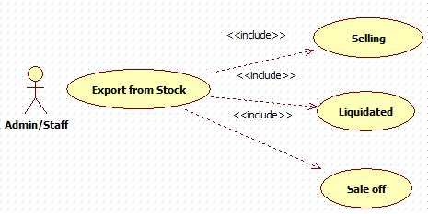

Store’s order
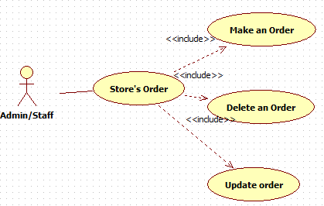

Searching
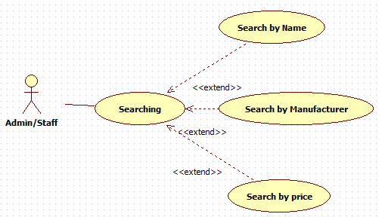

Staff Management

Staff Information
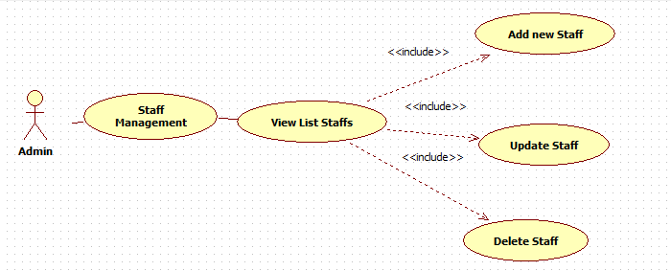

Staff Salary
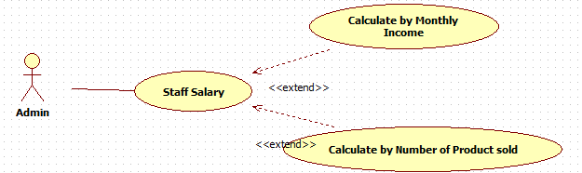

Report
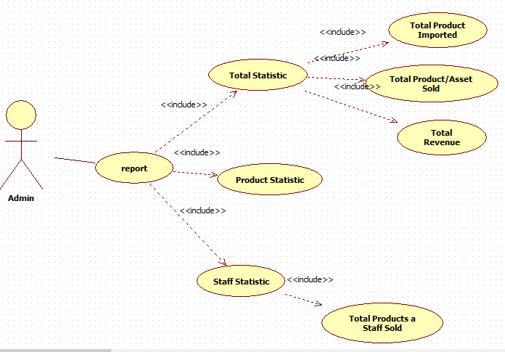

System Pages Flow
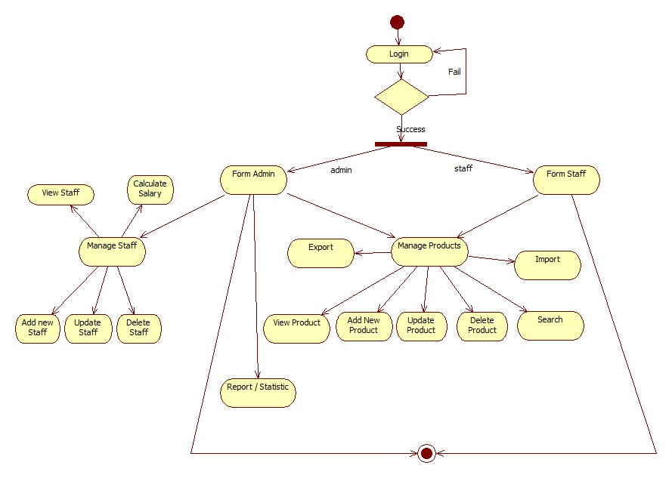

Functional Description

User interface:
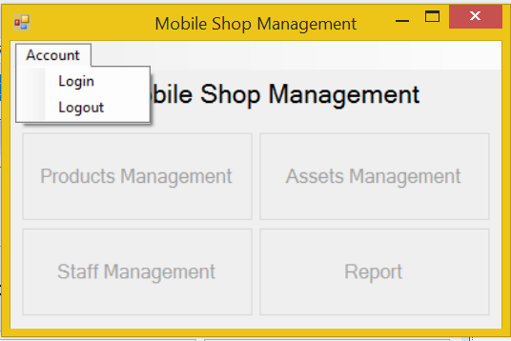
Screen | Mobile Shop Management – User interface
Description | Display a screen where user can control the product.
Screen Access | Users run program by click on file ProductManagement.exe
Screen Content
Item | Type | Data | Description
Mobile Shop Management | Label |  | Name of the software
Account | Menu strip item |  | Name of menu strip
Log in | Menu strip item |  | Open a dialog where user can log into program
Log out | Menu strip item |  | Log out the program.
Products Management | Button |  | If user click on this button, the “Products Management” dialog will appear.
Assets Management | Button |  | If user click on this button, the “Assets Management” dialog will appear.
Staff Management | Button |  | If user click on this button, the “Staff Management” dialog will appear.
Report | Button |  | If user click on this button, the “Report” dialog will appear.
Screen Actions
Action Name | Description |  | Success | Failure
Log in | Everyone have an account and click on it to enter the system. |  | Username of current user will display at the bottom of screen and all buttons will be enabled. | Displays message “Username or password is incorrect.”
Log out | Use to exit the system. |  | Username of current user at the bottom of screen will be disappeared and all button will be disabled. | Nothing.
Products Management | Search data which existed in database |  | “Products Management” dialog opened | Nothing.
Assets Management | Add more data. |  | “Assets Management” dialog opened | Nothing.
Staff Management | Remove some of data. |  | “Staff Management” dialog opened | Nothing.
Report | Update some exist fields of data. |  | “Report” dialog opened | Nothing.

Products Management:
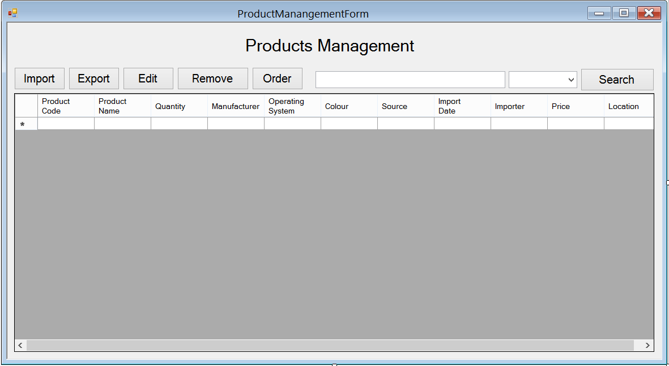
Screen | Products Management
Description |  | Show information of product, user can import new products, export(sell) them, edit their information, remove them. In case they run out of some products, they could order some more.
Screen Access |  | Users run program then click on Products Management button
Screen Content
Item |  | Type | Data | Description
Data grid view |  | Data grid view | Lookup all fields from PHONE table. | - Display all fields about the product when the form loaded: Product code, product name, quantity, manufacturer, OS, colour, source, import date, importer, price, location.  - This table is read-only, user cannot edit it.
Import |  | Button |  | User click on it to add new product
Export |  | Button |  | User click on it to add information of selling product into database
Edit |  | Button |  | User click on it to edit information of product
Remove |  | Button |  | User click on it to remove products in case they stop selling them
Order |  | Button |  | When the store run out of some product,or some new products that they don’t have, they could order their distributor to get them.
Search |  | Button |  | Search products by name, manufactor, price
Textbox |  | Text field – String (50) |  | Enter the keyword that user want to search
Combo box |  | Drop down list | name, manufactor, price | User choose which field they want to search by: name, manufactor, price
Screen Actions
Action Name |  | Description |  | Success | Failure
Import |  | Add information of new product |  | New product is added to database, show a message to notice | Show a message to notice, ask user to check the information and retry
Export |  | Add information of selling product |  | Show a message to ask the user to confirm that information | Show a message to notice, ask user to check the information and retry
Edit |  | Edit information of product |  | Show a message to ask the user to confirm that information | Show a message to notice, ask user to check the information and retry
Remove |  | Remove information of product |  | Show a message to ask the user if they comfirm to delete | Show a message to notice
Order |  | Make an order for new product |  | Show a message to ask the user if they comfirm to add information about order | Show a message to notice, ask user to check the information and retry
Search |  | Find a product in the table below. |  | Return the result of searching process | Message “Not found”.

Products Management – Import
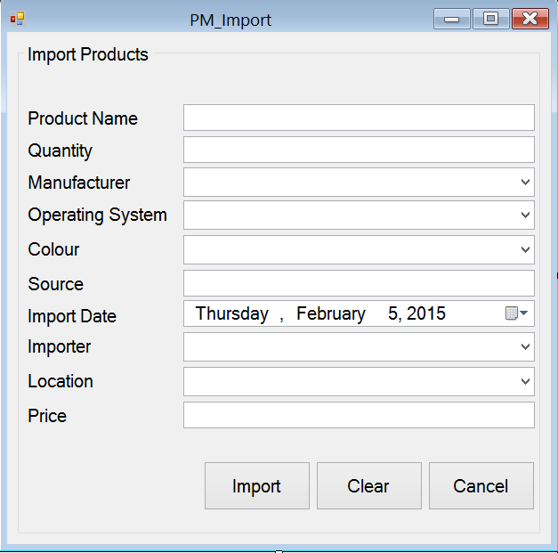
Screen | Product Management - Import
Description | Add new product to data base
Screen Access | Users run program by click on file Product Management -> Import
Screen Content
Item | Type | Data | Description
Import Products | String (50) | Hard code | A title lable
Product Name | Text field – String (50) | User input | The name of product
Quantity | Text field – String (50) | User input | The quantity of product
Manufacturer | Dropdown list – String (50) | Table MANUFACTURE.NAME | The name of the manufacture
Operating System | Dropdown list – String (50) | Table OPERATINGSYSTEM.NAME | The name of the Operating System
Colour | Dropdown list – String (50) | Table COLOR.VALUE | The color of Product
Source | Text field – String (50) | User input | Where the product has been made?
Import Date | Date time picker |  | When the product was imported?
Importer | Dropdown list – String (50) | Table STAFF.NAME | Who import that product?
Price | Text field – String (50) | User input | The price of the product
Import | Button |  | Inport new product
Clear | Button |  | Clear all the fields
Cancel | Button |  | Cancel importing action
Screen Actions
Action Name | Description |  | Success | Failure
Import | Inport new product |  | Show a message to notice | Show a message to notice, ask user to try
Clear | Clear all the fields |  | Set all the field empty,set all dropdown-list to default
Cancel | Cancel importing action |  | Close the import form

Products Management – Export
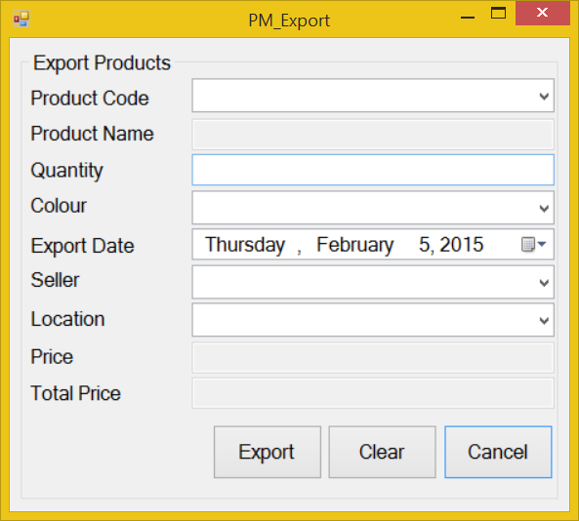
Screen | Product Management - Export
Description | Add information about selling product
Screen Access | Users run program by click on file Product Management -> Export
Screen Content
Item | Type | Data | Description
Export Products | String (50) |  | Title
Product Code | Dropdown list – String (50) | Table PHONE.CODE | The code of the product
Product Name | Text field – String (50) | Table PHONE.NAME | The name of the product
Quantity | Text field – String (50) | User input | The quantity of the product
Colour | Dropdown list – String (50) | Table COLOR.COLOR | The color of the product
Export Date | Date time picker |  | When the product was exported?
Seller | Dropdown list – String (50) | Table STAFF.CODE | Who sold the product?
Price | Text field – String (50) | Table PHONE.PRICE | The price of product
Total Price | Text field – String (50) | Price*Quantity | The total price of all product have been sold
Export | Button |  | Add information about selling product
Clear | Button |  | Clear all the fields
Cancel | Button |  | Close Export form
Screen Actions
Action Name | Description |  | Success | Failure
Export | Add information about selling product |  | Show a message to ask for confirmation, show message to notice the information has been added to database | Show a message to notice, ask user to try
Clear | Clear all the fields |  | Set all the field empty,set all dropdown-list to default
Cancel | Close Export form |  | Show a message to ask if they wanted to close the field

Products Management – Edit
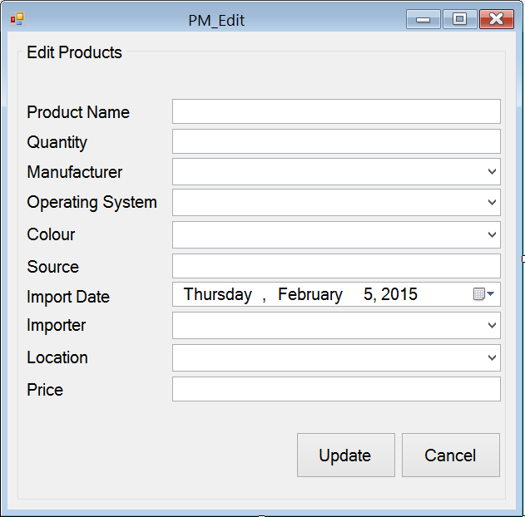
Screen | Product Management - Edit
Description | Edit information of product
Screen Access | Users run program by click on file Product Management -> Edit
Screen Content
Item | Type | Data | Description
Edit Products | String (50) | Hard code | Title
Product Code | Text field – String (50) | Table PHONE.CODE | The code of product
Product Name | Text field – String (50) | Table PHONE.NAME | The name of product
Quantity | Text field – String (50) | User input | The quantity of product
Manufacturer | Dropdown list – String (50) | Table MANUFACTURE.NAME | The manufacture of product
Operating System | Dropdown list – String (50) | Table OPERATINGSYSTEM.NAME | The operation system of product
Colour | Dropdown list – String (50) | Table COLOR.VALUE | The color of product
Source | Text field – String (50) | Table PHONE.SOURCE | Where the product has been made?
Import Date | Date time picker |  | When the product has been imported?
Importer | Dropdown list – String (50) | Table STAFF.CODE | Who imported the product?
Price | Text field – String (50) | Table PHONE.PRICE | The price of product
Update | Button |  | Click to update
Cancel | Button |  | Click to close the form
Screen Actions
Action Name | Description |  | Success | Failure
Update | Update phone |  | Show a mesage to notice | Show a mesage to notice, ask user to retry
Cancel | Close the form |  | Close the form

Products Management – Order

Order – Order Products
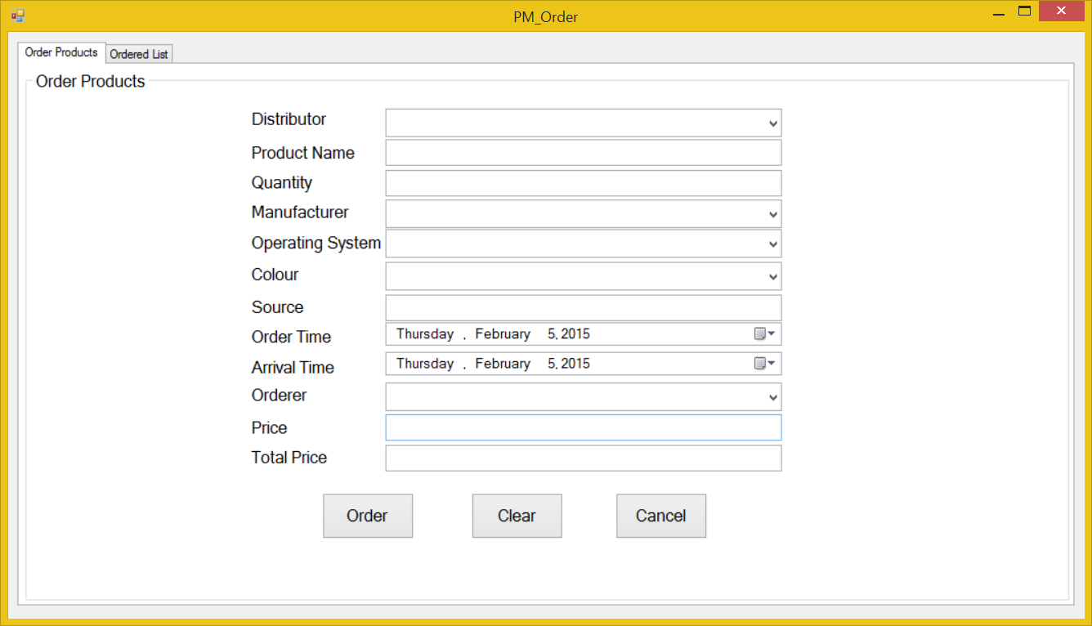
Screen | Product Management – Order
Description | Order the distributor new product in case they run out of product
Screen Access | Users run program by click on file Product Management -> Order
Screen Content
Item | Type | Data | Description
Order Products | Tab
Order Products | String (50) |  | Title
Distributor | Dropdown list – String (50) | Table DISTRIBUTOR.NAME | Who distribute that product?
Product Name | Text field – String (50) | User input | The name of the product
Quantity | Text field – String (50) | User input | The quantity of the product
Manufacturer | Dropdown list – String (50) | Table MANUFACTURER.NAME | The manufacturer of the product
Operating System | Dropdown list – String (50) | Table OPERATINGSYSTEM.NAME | The operating system of the product
Colour | Dropdown list – String (50) | Table COLOR.VALUE | The color of the product
Source | Text field – String (50) | User input | Where the product has been made?
Order Time | Date time picker |  | When did they ordered them?
Arrival Time | Date time picker |  | When will the product arrive?
Orderer | Dropdown list – String (50) | Table STAFF.CODE | Who ordered this product?
Price | Text field – String (50) | User input | The price of the product
Total Price | Text field – String (50) | Price*Quantity | The total price of all the products has been ordered
Order | Button |  | Add to database
Clear | Button |  | Clear all the fields
Cancel | Button |  | Close the form
Screen Actions
Action Name | Description |  | Success | Failure
Order | Add to database |  | Show a mesage to notice | Show a mesage to notice, ask user to retry
Clear | Clear all the fields |  | Set all the fields to empty
Cancel | Close the form |  | Close the form

Order – Ordered List
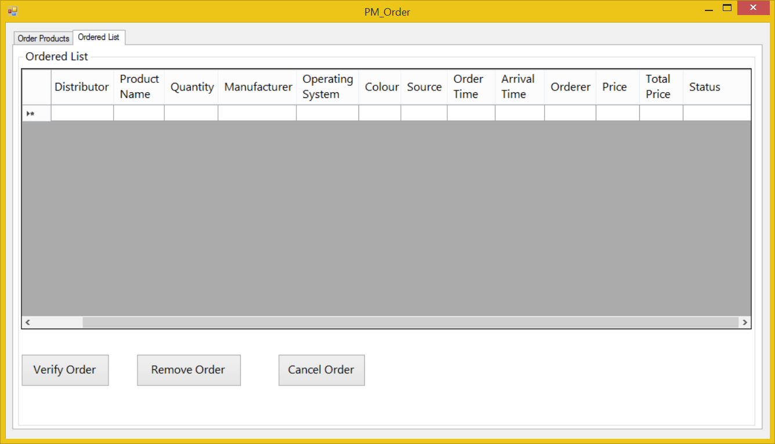
Screen | Product Management – Order-Order list
Description | Manage order
Screen Access | Users run program by click on file Product Management – Order-Order list
Screen Content
Item | Type | Data | Description
Order List | Label |  | Title
Order table | Data grid view | Table ORDER | Show order information
Verify order | Button |  | Verify order
Remove order | Button |  | Remove order
Cancel order | Button |  | Cancel order
Screen Actions
Action Name | Description |  | Success | Failure
Verify order | Verify order |  | Show a mesage to notice | Show a mesage to notice, ask user to retry
Remove order | Remove order |  | Show a mesage to notice, ask for confirmation | Show a mesage to notice, ask user to retry
Cancel order | Cancel order |  | Close the form

Assets Management:
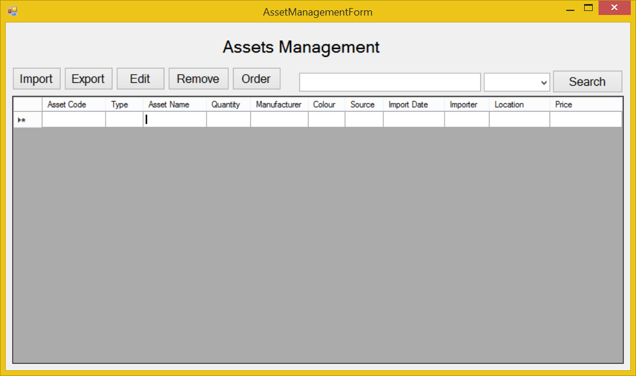
Use Case Name | Add products
Use Case ID | ABC001
High Level Requirement Ref | The general information about imported products must be prepared. The manager and the others members who have authority can view the product list. Besides that, they can make the order to import more products.
Actor | Shop’s Master, Warehouse Manager, Treasurer, Accountant
Description | This use case is used to add more products.
Pre-condition | The product is not available in the database.
Post-processing | The database has new products.

Screen | Assets Management
Description |  | Show information about asset
Screen Access |  | Users run program then click on Assets Management button
Screen Content
Item |  | Type | Data | Description
Data grid view |  | Data grid view | Lookup all fields from ASSET table. | - Display all fields about the asset when the form loaded: asset code, type, asset name, quantity, manufacturer, colour, source, import date, importer, location, price.  - This table is read-only, user cannot edit it.
Import |  | Button |  | User click on it to add new product
Export |  | Button |  | User click on it to add information of selling product into database
Edit |  | Button |  | User click on it to edit information of product
Remove |  | Button |  | User click on it to remove products in case they stop selling them
Order |  | Button |  | When the store run out of some product,or some new products that they don’t have, they could order their distributor to get them.
Search |  | Button |  | Search products by name, manufactor, price
Textbox |  | Text field – String (50) | User input | Enter the keyword that user want to search
Combo box |  | Drop down list | name, manufactor, price | User choose which field they want to search by: name, manufactor, price
Screen Actions
Action Name |  | Description |  | Success | Failure
Import |  | Add information of new product |  | New product is added to database, show a message to notice | Show a message to notice, ask user to check the information and retry
Export |  | Add information of selling product |  | Show a message to ask the user to confirm that information | Show a message to notice, ask user to check the information and retry
Edit |  | Edit information of product |  | Show a message to ask the user to confirm that information | Show a message to notice, ask user to check the information and retry
Remove |  | Remove information of product |  | Show a message to ask the user if they comfirm to delete | Show a message to notice
Order |  | Make an order for new product |  | Show a message to ask the user if they comfirm to add information about order | Show a message to notice, ask user to check the information and retry
Search |  | Find a product in the table below. |  | Return the result of searching process | Message “Not found”.

Assets Management – Import
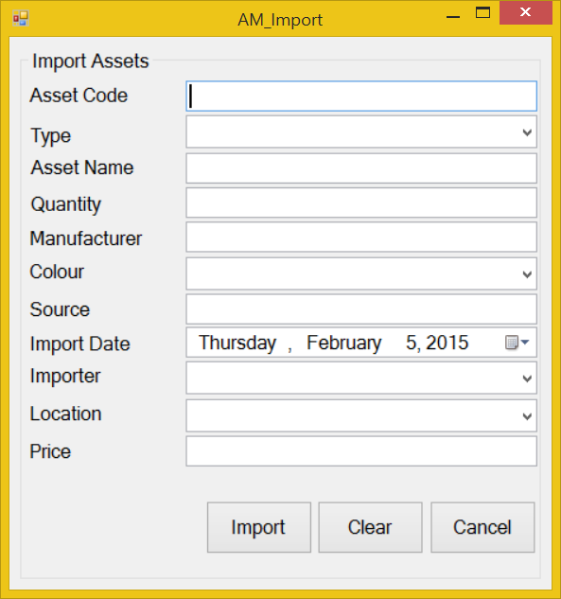
Screen | Asset Management - Import
Description | Add new product into data base
Screen Access | Users run program by click on file Asset Management -> Import
Screen Content
Item | Type | Data | Description
Import Products | String (50) | Hard code | A title lable
Product Name | Text field – String (50) | User input | The name of product
Quantity | Text field – String (50) | User input | The quantity of product
Manufacturer | Dropdown list – String (50) | Table MANUFACTURE.NAME | The name of the manufacture
Type | Dropdown list – String (50) | Table TYPE.NAME | What type of asset?
Colour | Dropdown list – String (50) | Table COLOR.VALUE | The color of Product
Source | Text field – String (50) | User input | Where the product has been made?
Import Date | Date time picker |  | When the product was imported?
Importer | Dropdown list – String (50) | Table STAFF.NAME | Who import that product?
Price | Text field – String (50) | User input | The price of the product
Import | Button |  | Inport new product
Clear | Button |  | Clear all the fields
Cancel | Button |  | Cancel importing action
Screen Actions
Action Name | Description |  | Success | Failure
Import | Inport new product |  | Show a message to notice | Show a message to notice, ask user to try
Clear | Clear all the fields |  | Set all the field empty,set all dropdown-list to default
Cancel | Cancel importing action |  | Close the import form

Assets Management – Export
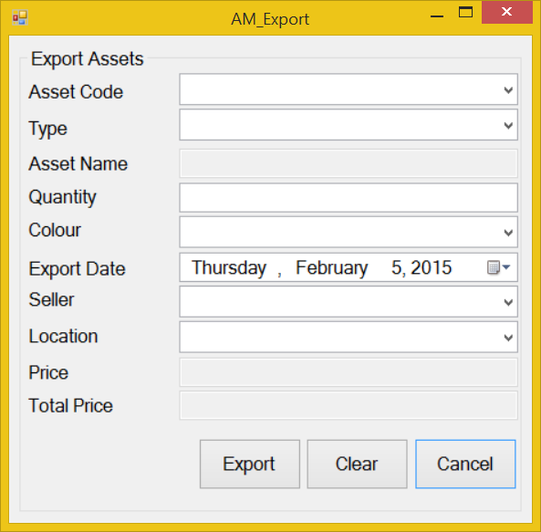
Screen | Asset Management - Export
Description | Add information about selling product
Screen Access | Users run program by click on file Asset Management -> Export
Screen Content
Item | Type | Data | Description
Export Products | String (50) |  | Title
Product Code | Dropdown list – String (50) | Table ASSET.CODE | The code of the product
Product Name | Text field – String (50) | Table ASSET.NAME | The name of the product
Quantity | Text field – String (50) | User input | The quantity of the product
Colour | Dropdown list – String (50) | Table COLOR.VALUE | The color of the product
Export Date | Date time picker |  | When the product was exported?
Seller | Dropdown list – String (50) | Table STAFF.CODE | Who sold the product?
Price | Text field – String (50) | Table ASSET.PRICE | The price of product
Total Price | Text field – String (50) | Price*Quantity | The total price of all product have been sold
Export | Button |  | Add information about selling product
Clear | Button |  | Clear all the fields
Cancel | Button |  | Close Export form
Screen Actions
Action Name | Description |  | Success | Failure
Export | Add information about selling product |  | Show a message to ask for confirmation, show message to notice the information has been added to database | Show a message to notice, ask user to try
Clear | Clear all the fields |  | Set all the fields to empty
Cancel | Close Export form |  | Show a message to ask if they wanted to close the field

Assets Management – Edit
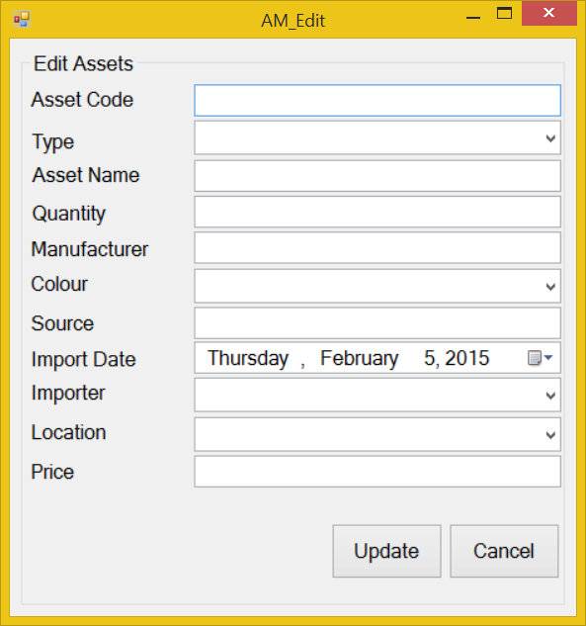
Screen | Asset Management - Edit
Description | Edit information of product
Screen Access | Users run program by click on file Asset Management -> Edit
Screen Content
Item | Type | Data | Description
Edit Products | String (50) |  | Title
Product Code | Text field – String (50) | Table ASSET.CODE | The code of product
Product Name | Text field – String (50) | Table ASSET.NAME | The name of product
Quantity | Text field – String (50) | Table User input | The quantity of product
Manufacturer | Dropdown list – String (50) | Table MANUFACTURE.NAME | The manufacture of product
Type | Dropdown list – String (50) | Table TYPE.NAME | The type of product
Colour | Dropdown list – String (50) | Table COLOR.VALUE | The color of product
Source | Text field – String (50) | Table ASSET.SOURCE | Where the product has been made?
Import Date | Date time picker |  | When the product has been imported?
Importer | Dropdown list – String (50) | STAFF.STAFFCODE | Who imported the product?
Price | Text field – String (50) | Table ASSET.PRICE | The price of product
Update | Button |  | Click to update
Cancel | Button |  | Click to close the form
Screen Actions
Action Name | Description |  | Success | Failure
Update | Update information of product |  | Show a mesage to notice | Show a mesage to notice, ask user to retry
Cancel | Close the form |  | Close the form

Assets Management – Order
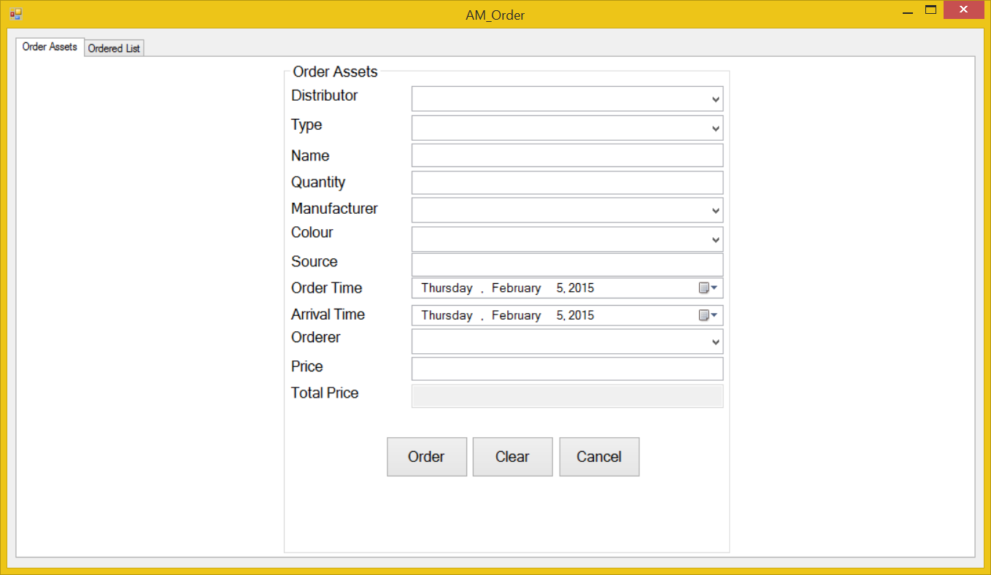
Screen | Asset Management – Order
Description | Order the distributor new product in case they run out of product
Screen Access | Users run program by click on file Asset Management -> Order
Screen Content
Item | Type | Data | Description
Order Products | Tab
Order Products | String (50) |  | Title
Distributor | Dropdown list – String (50) | DISTRIBUTOR.NAME | Who distribute that product?
Product Name | Text field – String (50) | User input | The name of the product
Quantity | Text field – String (50) | User input | The quantity of the product
Manufacturer | Dropdown list – String (50) | Table MANUFACTURER.NAME | The manufacturer of the product
Operating System | Dropdown list – String (50) | Table TYPE.NAME | The type of the product
Colour | Dropdown list – String (50) | Table COLOR.VALUE | The color of the product
Source | Text field – String (50) | User input | Where the product has been made?
Order Time | Date time picker |  | When did they ordered them?
Arrival Time | Date time picker |  | When will the product arrive?
Orderer | Dropdown list – String (50) | STAFF.STAFFCODE | Who ordered this product?
Price | Text field – String (50) | User input | The price of the product
Total Price | Text field – String (50) | Price*Quantity | The total price of all the products has been ordered
Order | Button |  | Add to database
Clear | Button |  | Clear all the fields
Cancel | Button |  | Close the form
Screen Actions
Action Name | Description |  | Success | Failure
Order | Add to database |  | Show a mesage to notice | Show a mesage to notice, ask user to retry
Clear | Clear all the fields |  | Set all the fields to empty
Cancel | Close the form

Order – Order Products
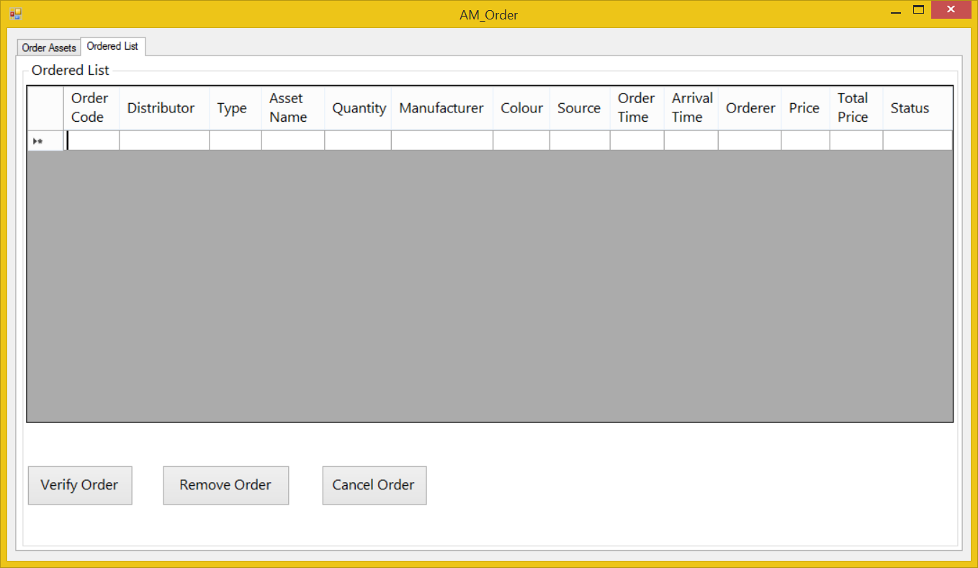
Screen | Asset Management – Order
Description | Manage order
Screen Access | Users run program by click on file Asset Management –> Order
Screen Content
Item | Type | Data | Description
Order List | Label |  | Title
Order table | Data grid view | Table ORDER | Show order information
Verify order | Button |  | Verify order
Remove order | Button |  | Remove order
Cancel order | Button |  | Cancel order
Screen Actions
Action Name | Description |  | Success | Failure
Verify order | Verify order |  | Show a mesage to notice | Show a mesage to notice, ask user to retry
Remove order | Remove order |  | Show a mesage to notice, ask for confirmation | Show a mesage to notice, ask user to retry
Cancel order | Cancel order |  | Close the form

Order – Ordered List
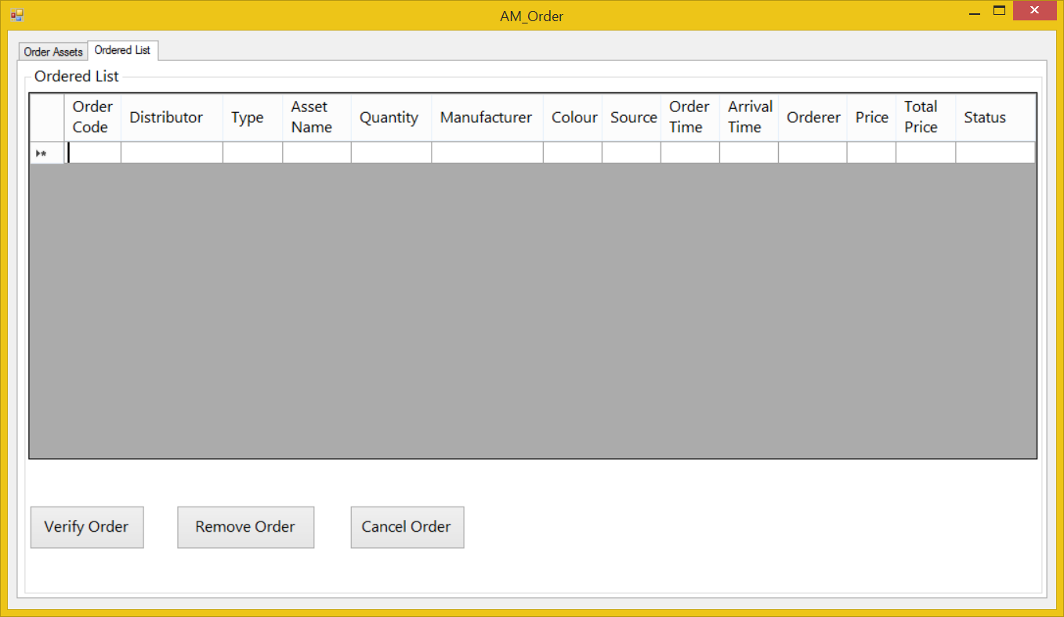
Screen | Product Management – Order – Order list
Description | Manage order
Screen Access | Users run program by click on file Asset Management –> Order->Order list
Screen Content
Item | Type | Data | Description
Order List | Label |  | Title
Order table | Data grid view | Table ORDER | Show order information
Verify order | Button |  | Verify order
Remove order | Button |  | Remove order
Cancel order | Button |  | Cancel order
Screen Actions
Action Name | Description |  | Success | Failure
Verify order | Verify order |  | Show a mesage to notice | Show a mesage to notice, ask user to retry
Remove order | Remove order |  | Show a mesage to notice, ask for confirmation | Show a mesage to notice, ask user to retry
Cancel order | Cancel order |  | Close the form

Staff Management
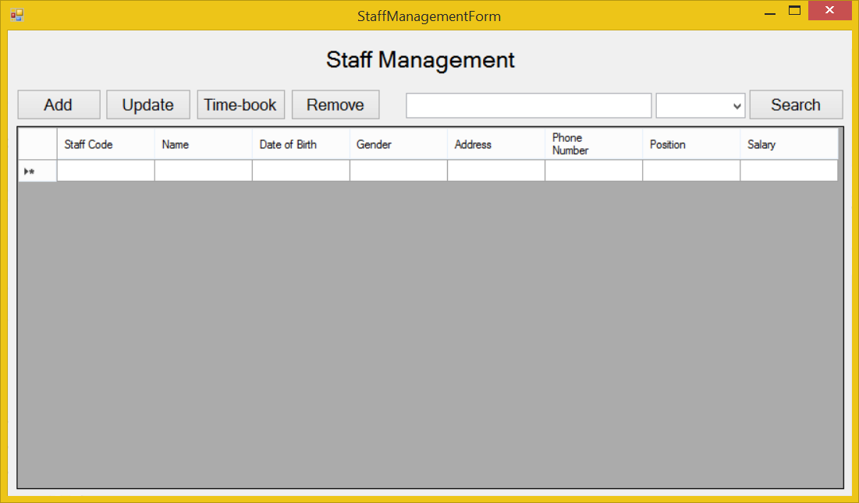
Screen | Staff Management
Description |  | Display a screen where user can manage their staff.
Screen Access |  | Users run program then click on Staff Management button.
Screen Content
Item |  | Type | Data | Description
Data grid view |  | Data grid view | Lookup all fields from STAFF table. | - Display all fields about the staff when the form loaded: staff code, name, date of birth, gender, address, phone number, position, salary.  - This table is read-only, user cannot edit it.
Add |  | Button |  | Open “Add Staff” dialog when user click it.
Update |  | Button |  | Open “Update Staff” dialog when user choose an item from data grid view and click this button.
Time-book |  | Button |  | Open “Time-book” dialog when user click it.
Remove |  | Button |  | Remove a staff when user choose an item from data grid view and click this button.
Search |  | Button |  | User click on it to search
Textbox |  | Text field – String (50) |  | User type their keyword to search
Combo box |  | Drop down list |  | Filter searching result by: Name
Screen Actions
Action Name |  | Description |  | Success | Failure
Add |  | Open “Add Staff” dialog |  | “Add Staff” dialog opened | Display a message “Cannot open ‘Add Staff’ dialog”.
Update |  | Open “Update Staff” dialog |  | “Update Staff” dialog opened | Display a message “Cannot open ‘Update Staff’ dialog”.
Time-book |  | Open “Time-book” dialog |  | “Time-book” dialog opened | Display a message “Cannot open ‘Time-book’ dialog”.
Remove |  | Remove a staff |  | Data grid view’s item removed. | Display a message “Cannot remove the chosen item”.
Search |  | Find a product in the table below. |  | Return the result of searching process | Display a message “Not found”.

Staff Management – Add
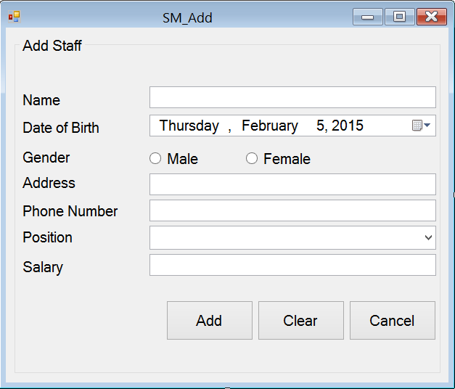
Screen | Staff Management – Add Staff
Description | Allow Administrator and Managers Account to add new staff members.
Screen Access | Users run program by click on file Staff Management -> Add
Screen Content
Item | Type | Data | Description
Add Staff | String (50) |  | Name of the form
Name | Text field – String (50) | Inserted into STAFF.NAME | This field is mandatory.  Name of staff member.
Date of birth | Date time picker | Inserted into STAFF.DOB | User pick the date from a date time picker
Gender - Male | Radio button | Inserted into STAFF.GENDER | This field is mandatory.  Gender of staff member (male)
Gender - female | Radio button | Inserted into STAFF.GENDER | This field is mandatory.  Gender of staff member (female)
Address | Text field – String (50) | Inserted into STAFF.ADDRESS | Address of staff member. This field is optional.
Phone number | Text field – String (50) | Inserted into STAFF.PHONENUMBER | This field is mandatory and number only. Managers need staff member’s phone number to contact.
Position | Dropdown list – String (50) | Inserted into STAFF.POSITION | This field is mandatory. Choose from the available position in the dropdown list.
Salary | Text field – String (50) | Inserted into STAFF.SALARY | This field is mandatory and number only.
Add | Button |  | Add data into database
Clear | Button |  | Clear all inputted data
Cancel | Button |  | Cancel “Add Staff”.
Screen Actions
Action Name | Description |  | Success | Failure
Add | Inputted data will be saved into the DB. |  | Display a message “A staff member has been added”.  Back to the “Staff Management” screen with new record on the table below (default list with all data).  When go back to the list from “Staff Management” screen, the new record will be focused on. | Display message: “Database connection error.”  Display message:  “Name must be entered.”  Display message:  “Gender must be chosen.”  Display message:  “Phone number must be entered.”  Display message:  “Position must be chosen.”  Display message:  “Salary number must be entered.”
Clear | Clear inputted data. |  | All field cleared. | Nothing.
Cancel | Close “Add Staff” dialog. |  | “Add Staff” dialog closed. | Nothing.

Staff Management – Update
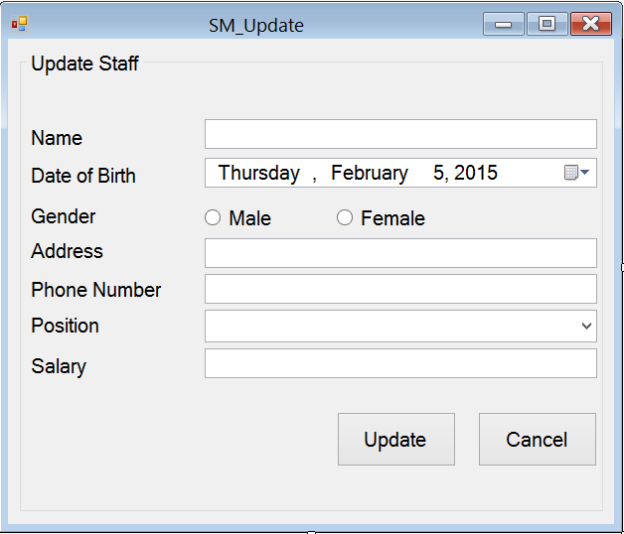
Screen | Staff Management – Update Staff
Description | Allow Administrator and Managers Account to update existing staff members.
Screen Access | Users run program by click on file Staff Management -> Update
Screen Content
Item | Type | Data | Description
Update Staff | String (50) |  | Name of the form
Name | Text field – String (50) | Look up from STAFF.NAME | This field is mandatory.  Name of staff member.
Date of birth | Date time picker | Look up from STAFF.DOB | User pick the date from a date time picker
Gender - Male | Radio button | Look up from STAFF.GENDER | This field is mandatory.  Gender of staff member (male)
Gender - female | Radio button | Look up from STAFF.GENDER | This field is mandatory.  Gender of staff member (female)
Address | Text field – String (50) | Look up from STAFF.ADDRESS | Address of staff member. This field is optional.
Phone number | Text field – String (50) | Look up from STAFF.PHONENUMBER | This field is mandatory and number only. Managers need staff member’s phone number to contact.
Position | Dropdown list – String (50) | Look up from STAFF.POSITION | This field is mandatory. Choose from the available position in the dropdown list.
Salary | Text field – String (50) | Look up from STAFF.SALARY | This field is mandatory and number only.
Add | Button |  | Add data into database
Cancel | Button |  | Cancel “Add Staff”.
Screen Actions
Action Name | Description |  | Success | Failure
Update | Inputted data will be saved into the DB. |  | Display a message “A staff member has been updated”.  Back to the “Staff Management” screen with new record on the table below (default list with all data).  When go back to the list from “Staff Management” screen, the new record will be focused on. | Display message: “Database connection error.”  Display message:  “Name must be entered.”  Display message:  “Phone number must be entered.”  Display message:  “Position must be chosen.”  Display message:  “Salary number must be entered.”
Cancel | Close “Update Staff” dialog. |  | “Update Staff” dialog closed. | Nothing.

Staff Management – Time-book
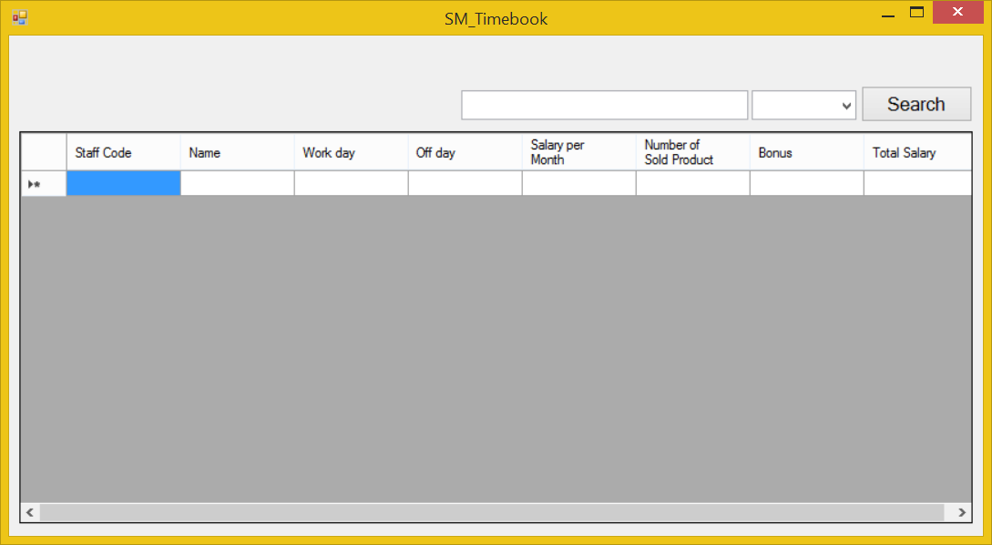
Screen | Staff Management – Time-book.
Description |  | Display a screen where user can manage staff member’s jobs.
Screen Access |  | Users run program then click on Staff Management -> Time-book
Screen Content
Item |  | Type | Data | Description
Data grid view |  | Data grid view | Lookup all fields from TIMEBOOK table. | - Display all fields about the staff’s time-book when the form loaded: staff code, name, work day, off day, salary per month, number of product sold, bonus, total salary.  - This table is read-only, user cannot edit it.
Search |  | Button |  | User click on it to search
Textbox |  | Text field – String (50) |  | User type their keyword to search
Combo box |  | Drop down list |  | Filter searching result by: Name
Screen Actions
Action Name |  | Description |  | Success | Failure
Search |  | Find a product in the table below. |  | Return the result of searching process | Display a message “Not found”.

Report

Report – Total Statics
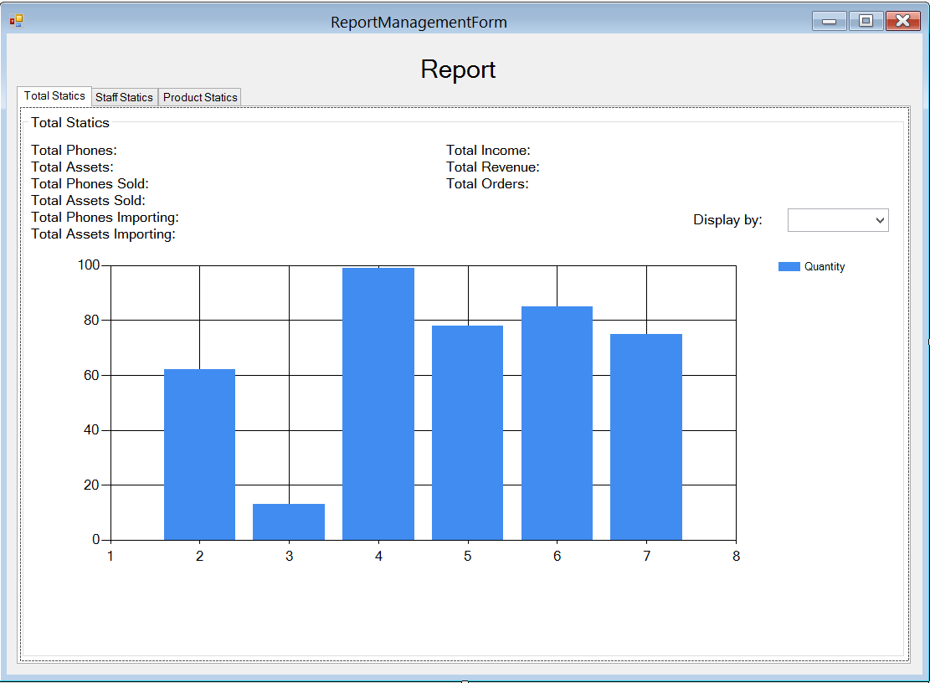
Screen | Report Management(total statics)
Description |  | Allow Administrator and Managers view their total statics in a month.
Screen Access |  | Users run program then click on Report button
Screen Content
Item |  | Type | Data | Description
Tab Total Statics |  | Tab |  | Display tab total statics
Total Phone |  | Label – String (50) | Count all available phones in table PHONE | Display total available phones in DB.
Total Assets |  | Label – String (50) | Count all available phones in table ASSET | Display total available assets in DB.
Total Phone Sold |  | Label – String (50) |  | Display total phones sold.
Total Assets Sold |  | Label – String (50) |  | Display total assets sold.
Total Phone Importing |  | Label – String (50) |  | Display phones which are importing.
Total Assets Importing |  | Label – String (50) |  | Display assets which are importing.
Total Income |  | Label – String (50) |  | Display total income.
Total Revenue |  | Label – String (50) |  | Display Total Revenue
Total Orders |  | Label – String (50) |  | Display Total Orders
Display by |  | Drop down list – String (50) |  | Display information in chart below by total phones, assets; total phones, assets sold; total importing phones, assets; total income, revenue, orders.
Chart |  | Chart |  | Display data when user choose an item from dropdown list.  X-axis is days of a month.  Y-axis is quantity.  The chart in the image above is just an example.
Screen Actions
Action Name |  | Description |  | Success | Failure
Choose |  | Choose an item from combo box “Display by:” |  | Display information to the chart below. | Display message: “Database connection error.”

Report – Staff Statics
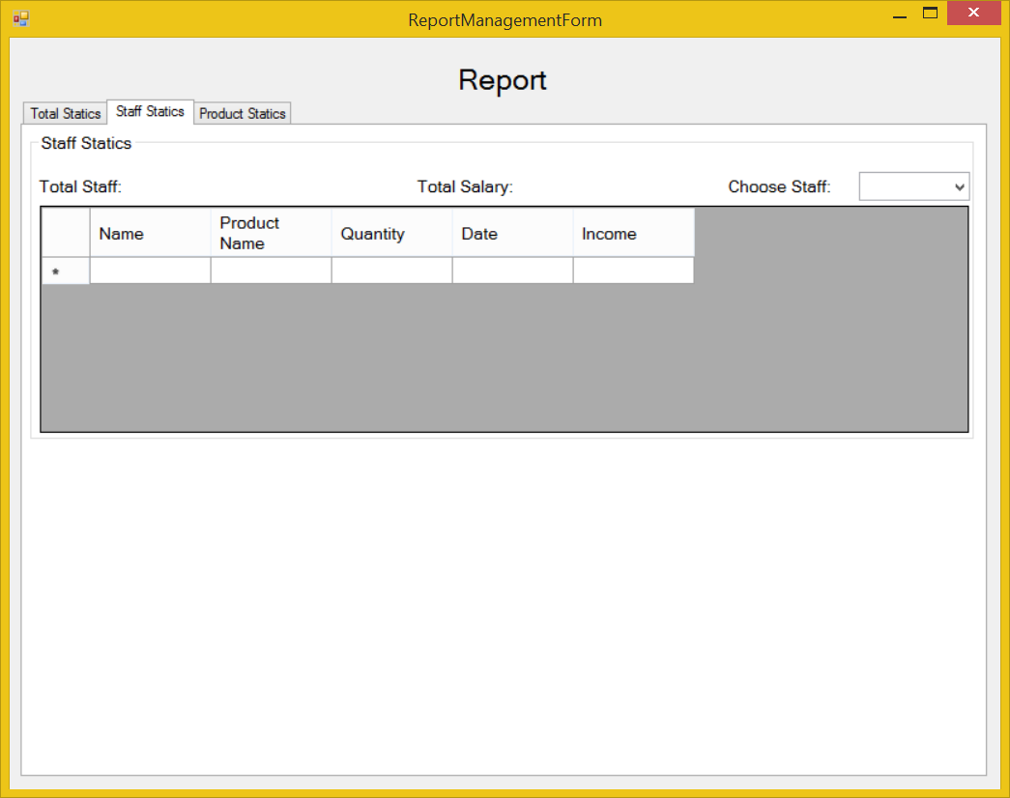
Screen | Report – Staff Statics
Description | Allow Administrator and Managers view their statics about staff members.
Screen Access | Users run program by click on file Report -> Staff Statics
Screen Content
Item | Type | Data | Description
Staff Statics | Tab |  | Tab name
Staff Statics | Label – String (50) |  | Name of the staff statics group
Total Staff | Label – String (50) | Look up from STAFF, count all of available staff members in DB except Administrator. | Display total available staff members in DB.
Total Salary | Label – String (50) |  | Display total available salary of all staff members in DB.
Choose Staff | Combo box | Look up from STAFF.STAFFCODE | Choose a staff code from the dropdown list to view information at a specific staff member in data grid view below.
Data grid view | Data grid view |  | - Display all fields about the staff when the staff code is chose: Name, product name, quantity, date, income.  - This table is read-only, user cannot edit it.
Screen Actions
Action Name | Description |  | Success | Failure
Choose. | Choose an item from combo box “Choose Staff:” |  | Display information to the data grid view below. | Display message: “Database connection error.”

Report – Product Statics
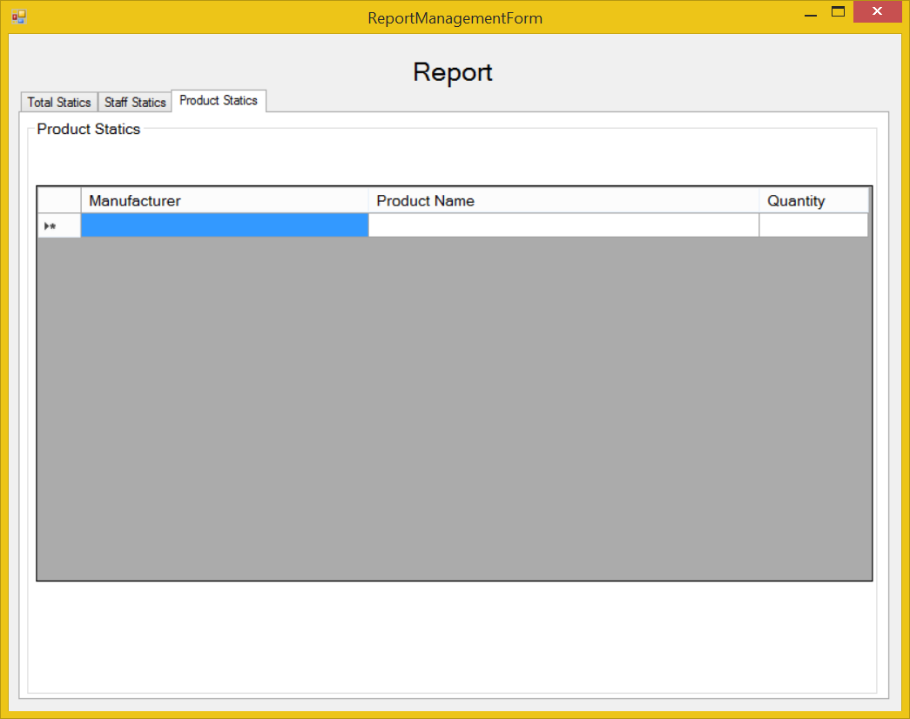
Screen | Report – Products Statics
Description | Allow Administrator and Managers view their statics about products.
Screen Access | Users run program by click on file Report -> Product Statics
Screen Content
Item | Type | Data | Description
Products Statics | Tab |  | Tab name
Products Statics | Label – String (50) |  | Name of the Products statics group
Data grid view | Data grid view | Look up from PHONE.MANUFACTURER and ASSET.MANUFACTURER join with PHONE.NAME and ASSET.NAME then count all them. | - Display all fields about the Products when the form loaded: Manufacturer, product name, quantity.  - This table is read-only, user cannot edit it.
Screen Actions
Action Name | Description |  | Success | Failure

NON-FUNCTIONAL REQUIREMENTS AND OTHERS

Performance
No. | Requirement
1. | Allow at least 10 users access at the same time
2 | Can run on computer with 512MB of RAM or higher, 1.7 GHz of CPU or higher, Windows XP 32bit or higher
3 | Used maximum 256MB of disk space (not include database)

Scalability
No. | Requirement
1. | Allow admin to limit the maximum of user access the system at the same time
2 | Allow developer to add more type of user with the different authority
3 | Allow admin to create more user account

Security
No. | Requirement
1. | Protect customer information
2. | Ensure the integrity, security of data
3 | Decentralize the user
4 | Protect internal information
5 | The system’s back-end databases shall be encrypted.

Network
No | Requirement
1 | Allow the manager to manage the store from home using the internet

Backup and restore
No | Requirement
1 | The system can synchronize automatically every day
2 | In case the system get error, it can restore, back to the status before getting error

Reliability
No | Requirement
1 | Only administrator can change product information
2 | Every changed of price have to be confirmed by the manager
3 | The system shall provide storage of all databases on redundant computers with automatic switchover.

Interfaces
No. | Requirement
1. | Font style is the same with http://www.customer.com.sg/default.aspx
2 | The GUI must have no more than 10 buttons each form
3 | The menu must have no more than 5 submenus
4 | Use the fresh color like the yellow green, blue, green, yellow .etc.

User manual and help
No | Requirement
1 | The software shall show the Use guide in the first running
2 | The software shall have a Help menu to show the Use guide in case users don’t know how to use or what is the purpose of the function

Extensibility
No. | Requirement
1. | Can add more table record without conflictions with the older
2. | Allow the developer to add more functions without conflictions
3 | The software can provide data to other application on other platform

APPENDIX

